Kelly St. Pierre
CSC500-1
Critical Thinking Module 1
January 17, 2026

Pseudocode:

Source Code:

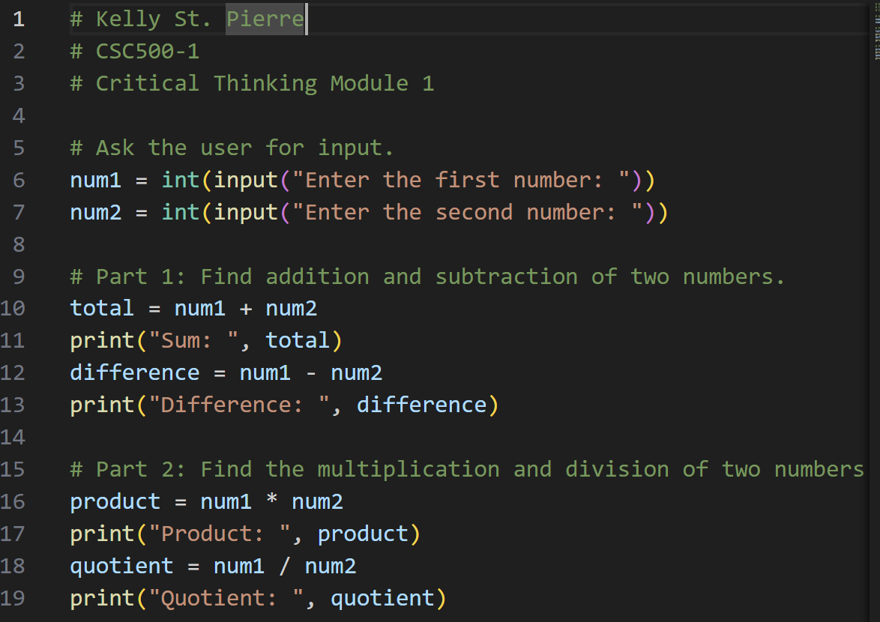

Outputs:

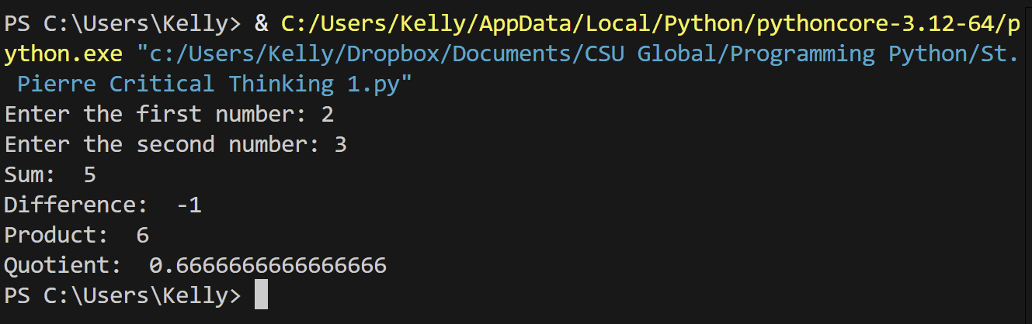

Git Repository:

